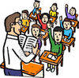
Entrada # ___: Capítulo 1ª vocabulario

^{1.}español | ^{2.}inglés | ^{3.}imagen
to talk about what you do in class

to talk about classroom rules
to name school objects

negative and affirmative words

other useful words

verbs

