1. _______________________
2. _______________________
3. _______________________
4. _______________________
5. _______________________
6. _______________________
7. _______________________
8. _______________________

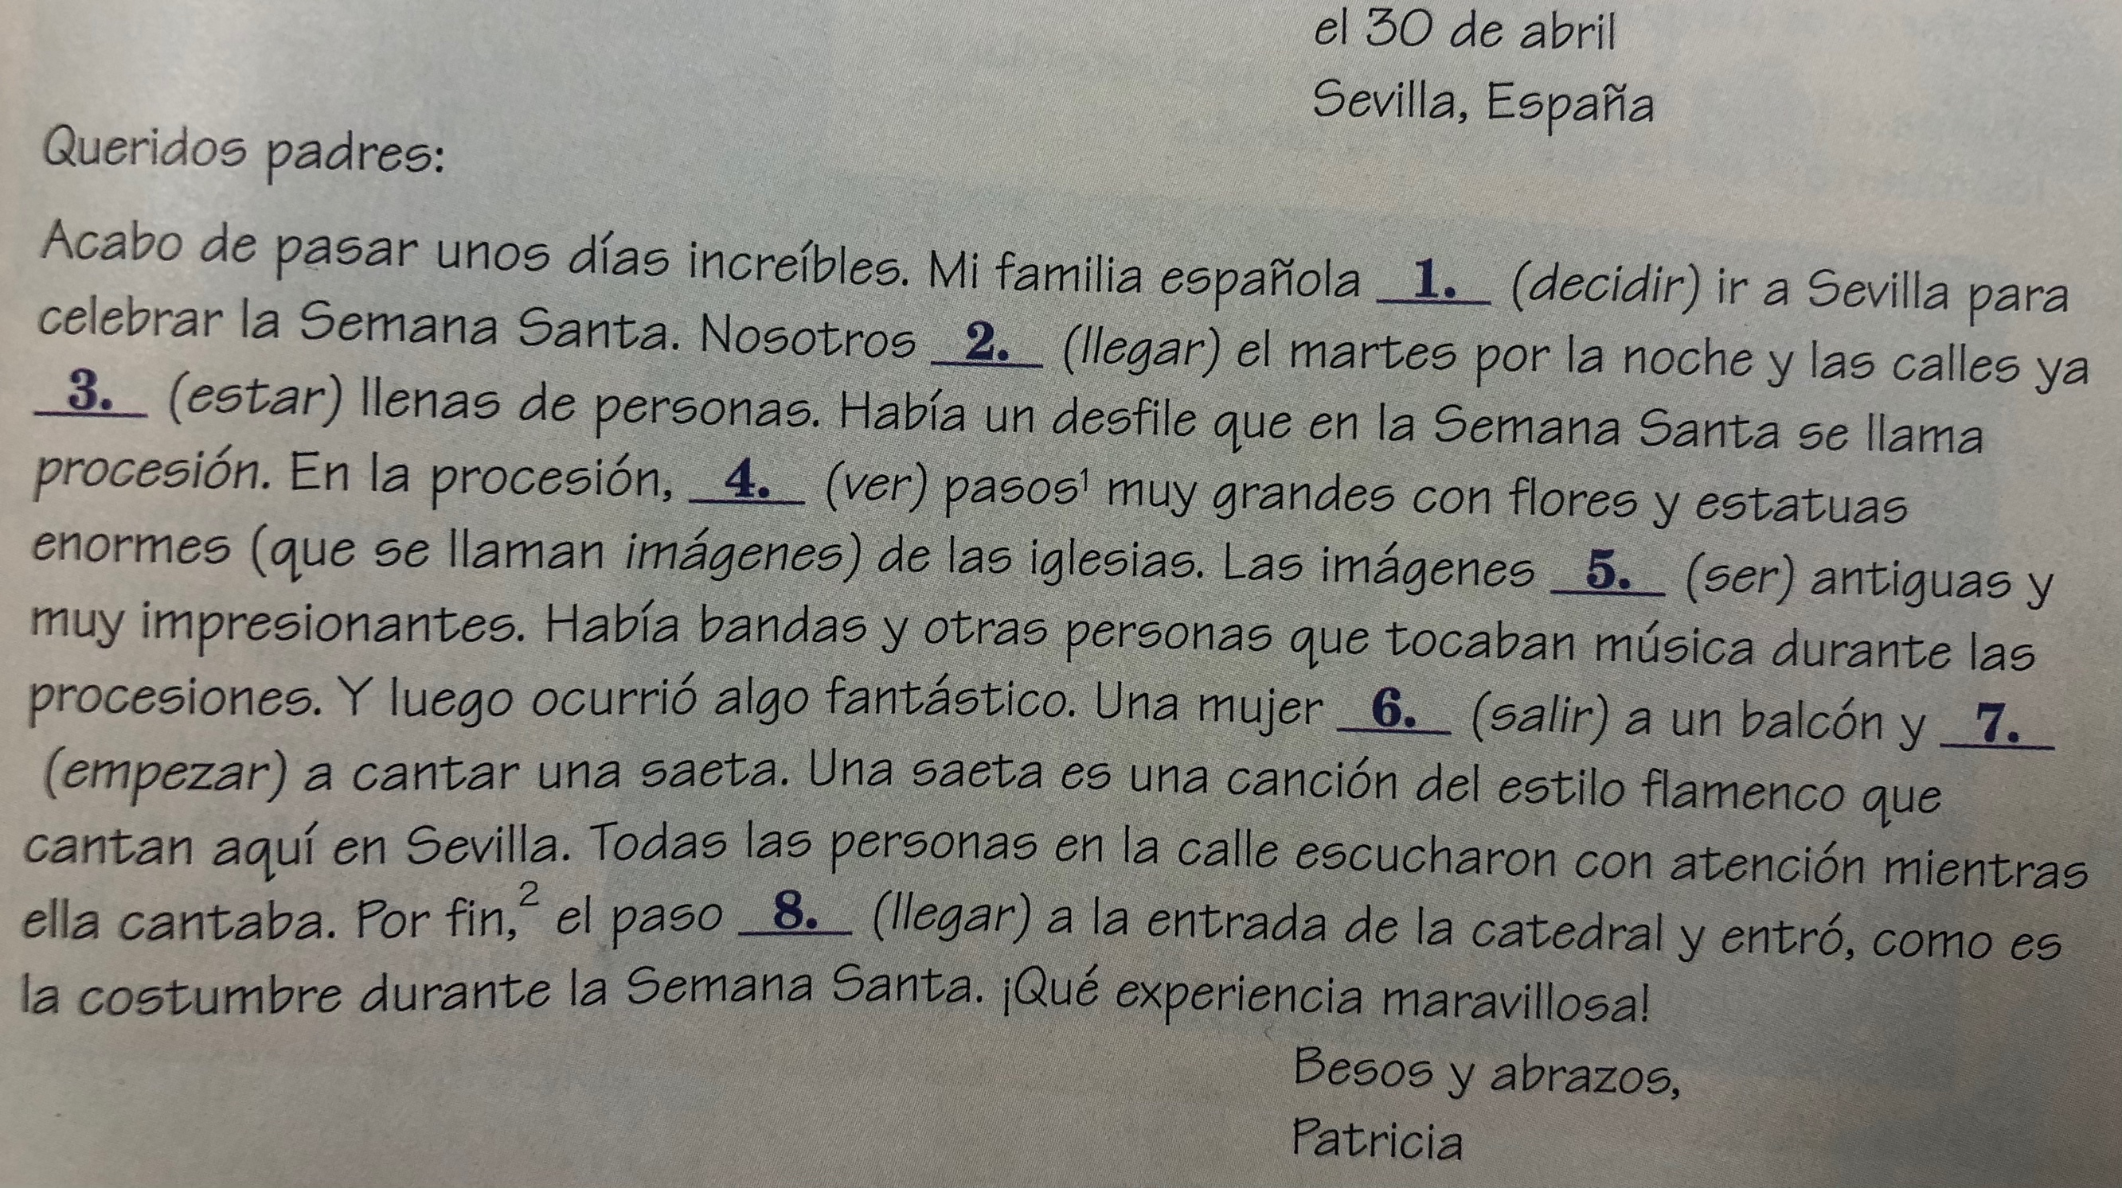

**Instrucciones**: Completa la descripción con las formas apropriadas del pretérito o del imperfecto

**Practica:**

* In addition to saying what someone _______ to do, the imperfect tense is used:

to describe ____________, _______________, and ___________________ in the past.

* Ej: La casa de mis abuelos ________ enorme. ________ cinco dormitorios.

__________________________________. ________________________.

* to talk about a past __________ or _______________ when NO ________________ or ________ is specified.
* Ej: ___________ mucha gente en la casa para el aniversario de mis abuelos.

____________________________________________________________

* to describe the _________________ or ________________ information when something else happened or _______________ the __________ action. In these cases, the imperfect tense is used to tell what someone ______________ when something __________________ (preterite).
* Ej: Todos mis parientes ____________ cuando ______________.

___________________________________________________

**Entrada #____: the imperfect tense: describing a situation**

*Capítulo 4B*